GUI Printouts:   
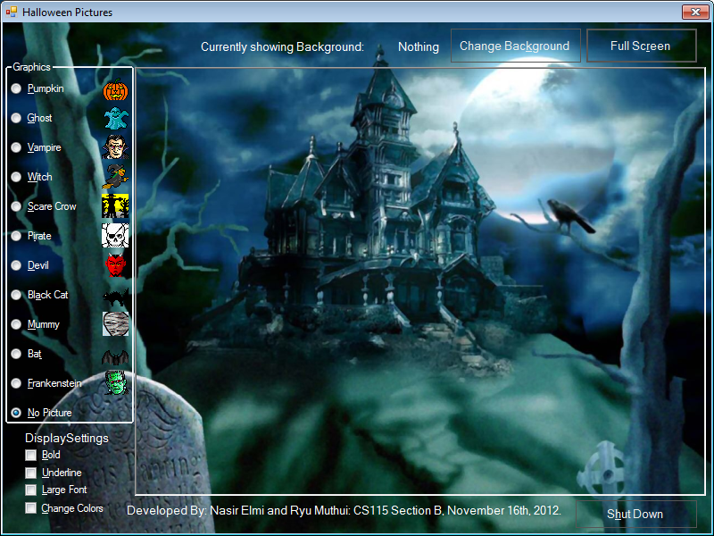

This is the GUI as it comes up at program start.

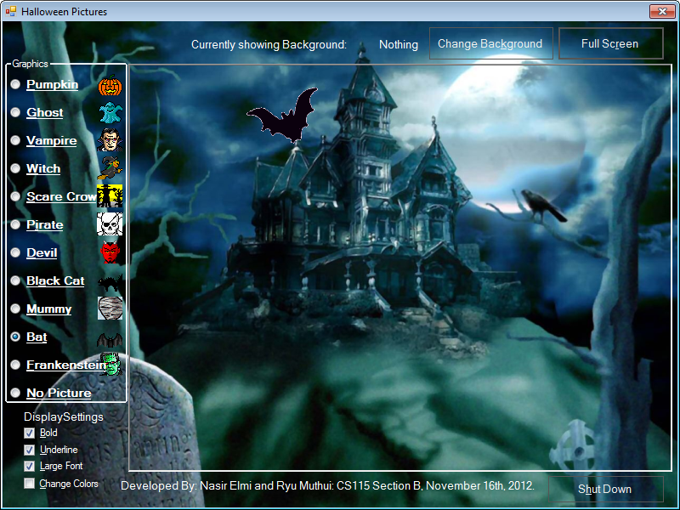

This is the GUI with text option checkboxes selected.

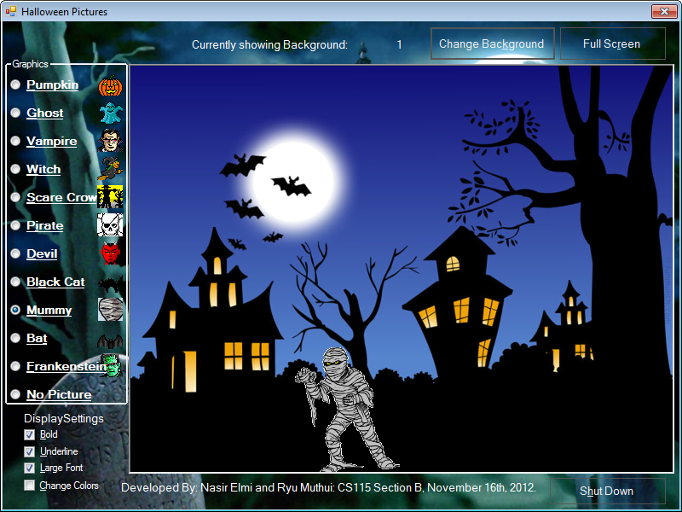

This is the GUI with a picture graphic selected on a different background.



This is the GUI in Full Screen Mode with Change Colors option selected.